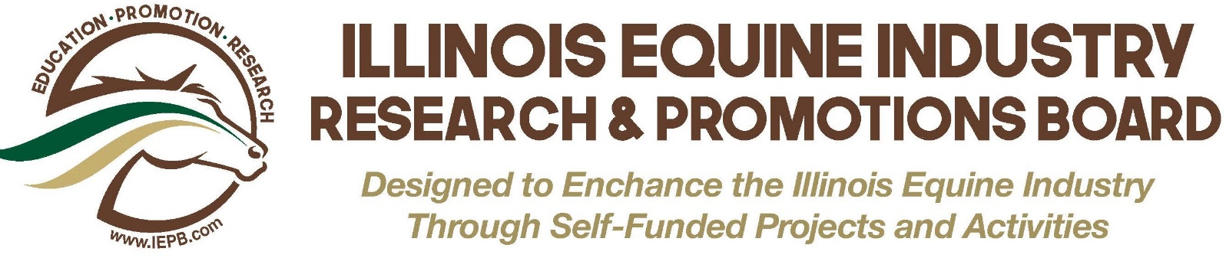

ILLINOIS EQUINE INDUSTRY RESEARCH AND PROMOTION BOARD
PROJECT APPLICATION COVER SHEET

Applicant: ____________________________________________________________________
(Name of organization, if applicable-as it appears on the IRS Determination Letter)

Project Title____________________________________________________________________

Applicant Address_________________________________________________________________________

Project Location/Address (Include County)_____________________________________________________

Contact Person: __________________________________________________________________________
(Name, title email and telephone #)

Amount Requested:______________ Total Cost of Project:_____________ Other funds Raised _________

PROJECT or EDUCATION GRANT (circle one)
List previous IEPB funding
Year | Amount | Project

In the space below-provide a brief description of your organization and its primary purpose/objectives.
Website:___________________________________

Answer all the following questions within the 5-page limit. Use the following headings.
Double-space, font size no smaller than 12 point. One-inch margins. Number pages.
Use only one side of paper. Staple in upper left-hand corner. Do not use binders.

- Describe the project –Who will benefit? How many will benefit (persons/horses)? What facilities will be used to conduct the project? Does the applicant own the property? What will the final product be? Why is this project important? Describe in such detail that the reader may visualize the project.
- Why is this project significant? Detail how this project promotes equine industry or education.
- Methodology – How will you accomplish the project?
- Timeline – What happens when? (Project must be completed within 12 months of receipt of grant.)
- Animals – If animals are used, explain how they are used and how they will be protected.
- Other Agencies- If applicable, list other agencies involved with this project and their role.

ADDITIONAL INFORMATION (Not included in 5-page limit)
- Copy of at least one feed receipt showing the assessment has been paid. Identify three (3) feed dealers (company name and address) that participate in the check-off program within a 100-mile radius of the potential grant recipient.
- Staffing – Include title/brief position description of all personnel involved with this project. Include volunteers. Do not include full resumes.
- Budget & Justification
  - One-page project budget.
  - Justification: Detail how costs were determined. (Include bids for equipment and/or estimate from contractor.)
  - Justification: Explain how balance of funds will be raised if project cost greater than grant request.
- Other Funders – List all organizations to which you have submitted this proposal and their response and/or when response is expected.
- 501 (c)(3) IRS Tax Determination Letter copy – IF APPLICABLE.
- Organization’s budget for current fiscal year – Summary, no more than one page.
- Letters of Support (at least 2).
- References- List name, address, email and phone number of three (3) references.
- IF APPLICABLE - Letters of commitment or memorandums of understanding.

Applications must be RECEIVED by 4 PM November 15. When that date falls on weekend - proposals are due by 4PM the following Monday. Email and fax proposals will not be accepted.

A complete grant application includes:
____ Coversheet
____ Responses (5-page limit)
____ Additional Information (see above)

Send 1 original and 12 copies of complete grant applications to
Illinois Equine Industry Research and Promotion Board
2601 South 5th Street
Springfield, IL 62791 Phone (217) 529-6503

